Custom domain and SSL configuration

1. For custom domain configuration, go to the custom domain option

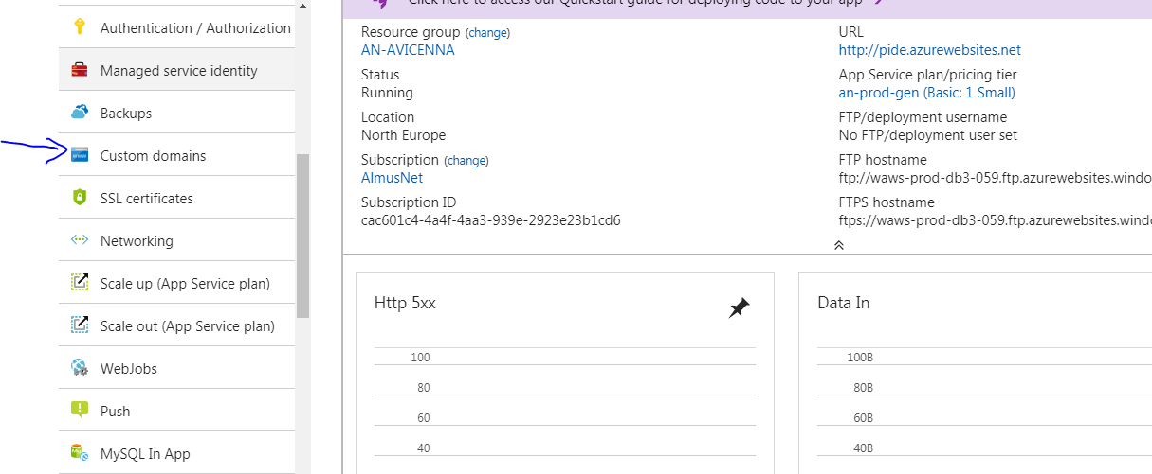

1. Add custom domain (After DNS update from sysops department) and validate in azure portal

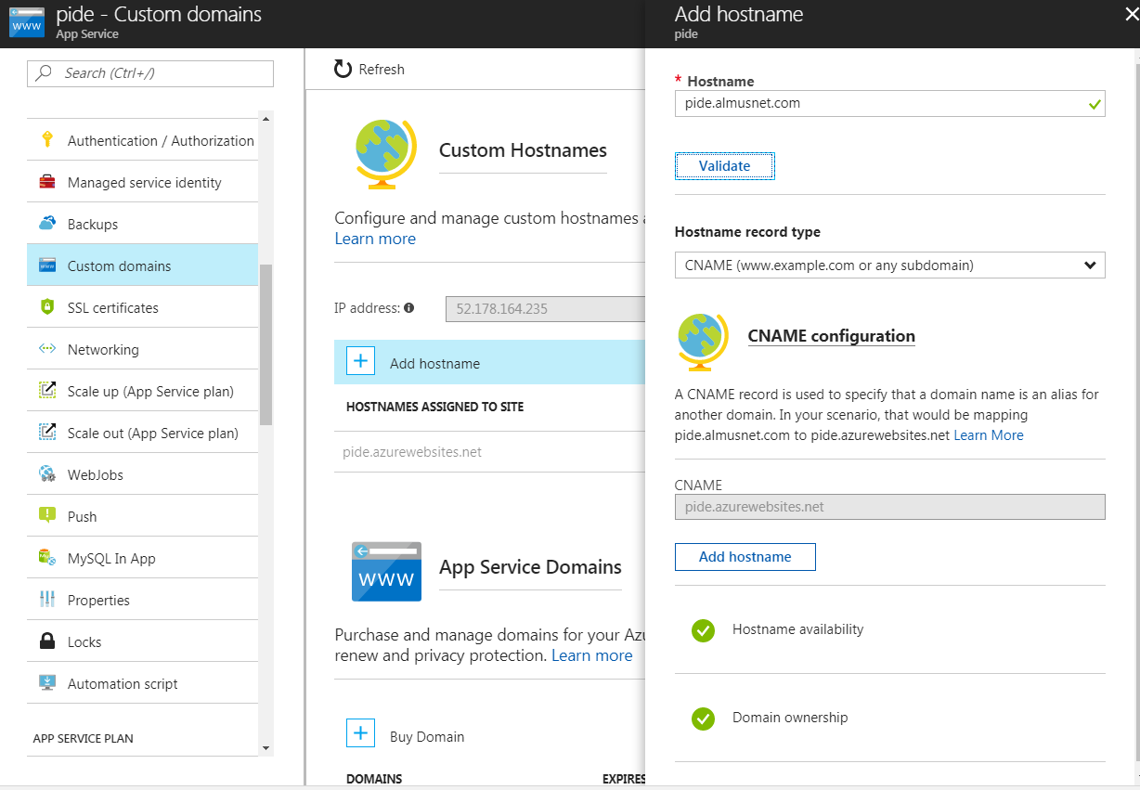

After validation, **Add Hostname**

1. SSL Certificates uploading and binding with custom domain

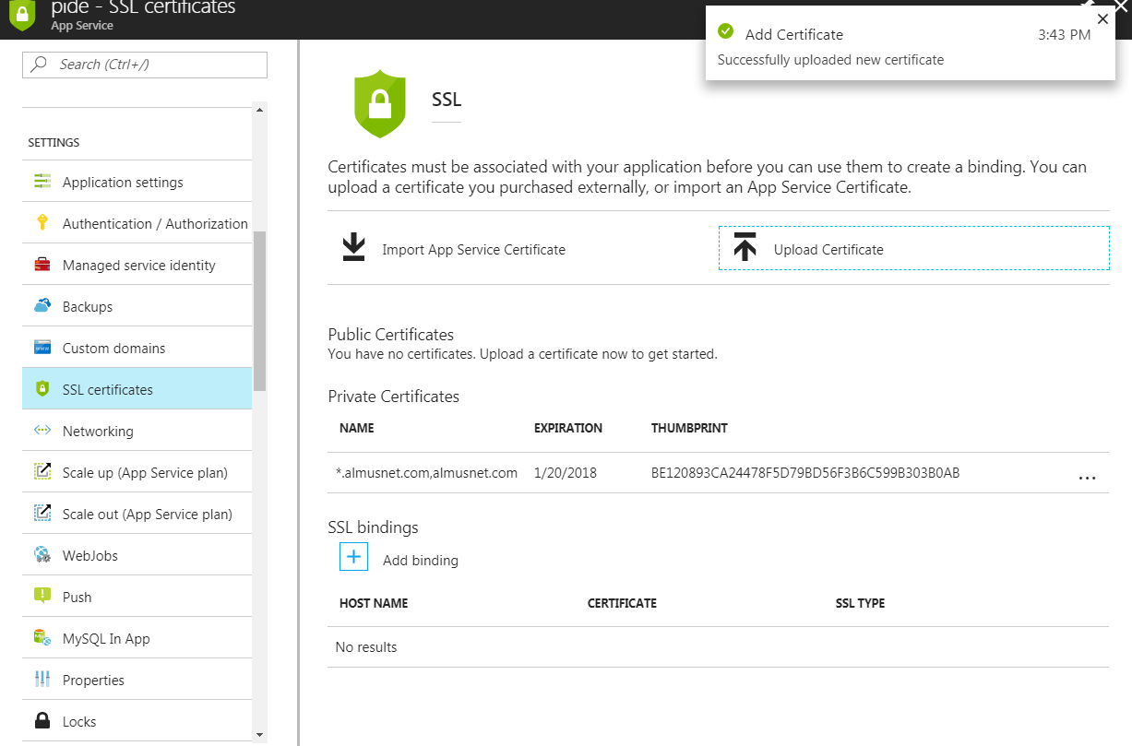

1. Bind SSL with Custom domain

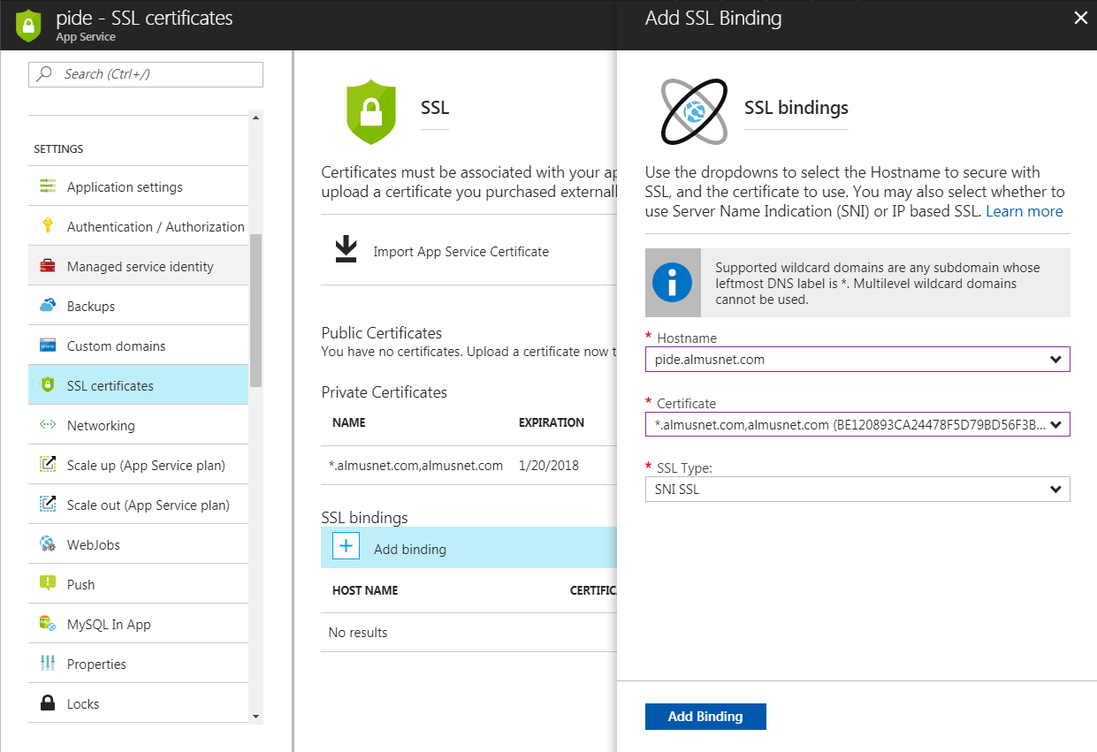

1. Redirection of HTTP to HTTPS (Extension addition on web app)

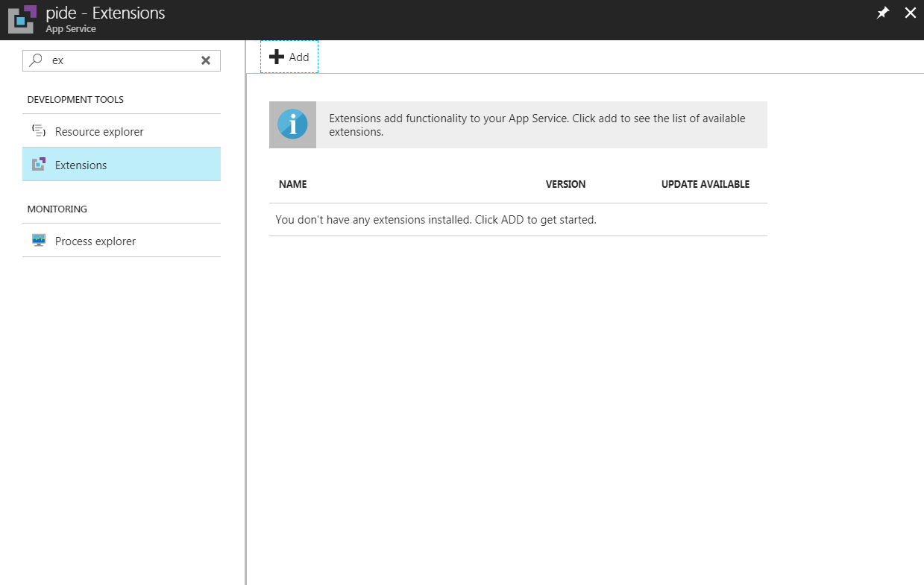

Extension Gallery

